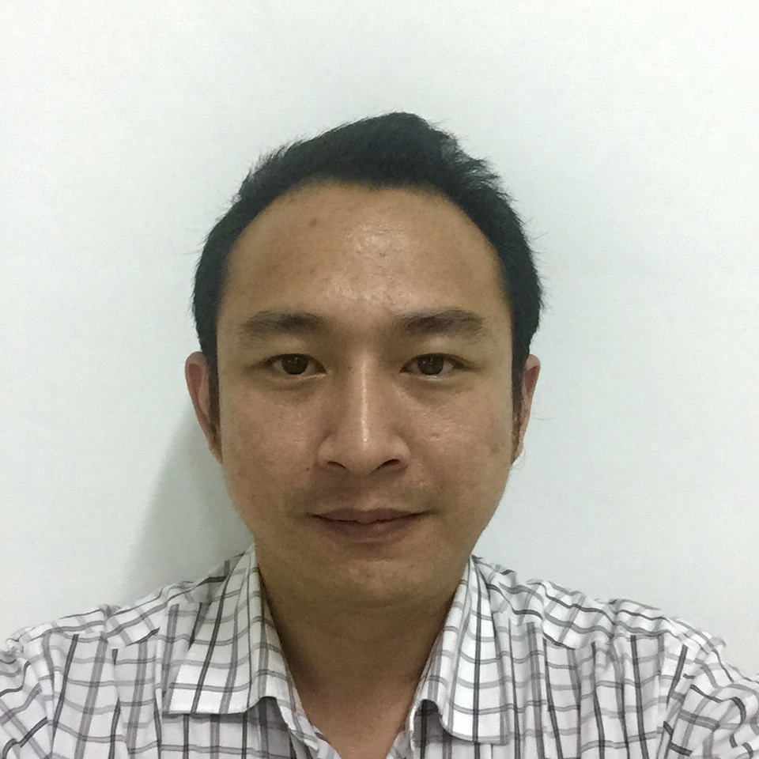

##### CURRICULUM VITAE

A. PERSONAL INFORMATION

* Full Name : **Christian Lisangan**
* Place and Date of Birth : Malang-Indonesia, December 25, 1980
* Sex : Male
* Marital Status : Married
* Religion : Catholic
* Status : Singapore Citizen
* IC Number : S8061484E
* Address : Blk 242 Bukit Batok East Ave 5

#05-192, Singapore 650242

* Cellular Phone Number : +65-90608488
* Home Phone Number : +65-67293518
* E-mail Address : christian_lie80@hotmail.com

**PROFILE**

Experienced Professional with ten years experiences of General Accounting/Auditing and Business Operational Management. I am a self-starter and quick learner, recognized skills in mentoring and mediating between employees, and in leading team tasks.

**CAREER OBJECTIVE**

To pursue a profession in the Finance/Operational area where ensure supervision, management, and analytical skills are superior.

**AREA OF EXPERTISE**

|  |  |  |
| --- | --- | --- |
| * Financial Analysis | * Financial Reporting | * GST Reporting |
| * CPF Process and Calculating | * LC Process | * Claim Processing |
| * Audit Procedures |  |  |

**COMPUTER AND TECHNICAL SKILL**

* Microsoft Office
* ACCPro (AAPR4) Accounting System
* SAP (Minor)
* Sealing Solution for Pump
* MYOB

B. EDUCATION BACKGROUND

Tarumanagara University, 2001-2006

Jakarta, Indonesia

Majored in Accounting, minored in auditing

Bachelor Degree

C. WORK EXPERIENCE

**1. January 2006 – Augustus 2008**

Company : Johan Malonda Astika & Rekan, Public Accounting Firm,

(Member of Baker Tilly International)

Address : Jl. Pluit Raya 200 blok V no 1-5 Jakarta Utara, Indonesia 14450

Position Title : January 2006 – July 2006 **Technical Assistant**

August 2006 – January 2007 **Assistant Team Leader**

February 2007 – November 2007 **Team Leader**

December 2007 – August 2008 **Account Holder (Senior Audit)**

Responsibility :

* Participated in certified audit of clients in fields of trading, packaging, CMT & Textile Export, Manufacturing, Assembling & Electronic Product Sales, Cement, Freight Forwarding Service, Oil palm, Coal Mining, Etc.
* Responsible for the review consisting of analysis, verification, and confirmation. The review provided management with assurance that effective controls and policies were being administrated.
* Preparation of financial reports and statements, and consolidation.
* Responsible for Review and Compilation Services.
* Responsible for whole engagements with limited supervision.
* Management advisory services for clients.

Achievement:

* Entrusted to supervise and managing a team of Audit Assistants within one year of hire.

**2. October 2008 – Present**

Company : Pitman Technologies Pte Ltd

Address : 105 Sophia Road #02-01, Casa Sophia, Singapore 228170

Position : Operation Manager & Accountant

Current Salary : S$ 2,500.00

Responsibility

* Responsible of handling full sets of accounts and preparation of monthly financial closing.
* Processing payments to suppliers and staff claims.
* Tracking and ensuring prompt payment by customers.
* Maintaining proper accounting records in ERP system and carry out periodic reconciliation.
* Responsible of the GST preparation.
* Responsible for year-end audit preparation.
* Participated in financial planning and cash flow reporting.
* Preparing Quotation, Purchase Order and Invoice.
* Preparing and submission monthly CPF contribution.
* Preparing and submission LC transaction.
* Liaise with bank and Corporate Secretary.
* Liaise with Indonesia Embassy for Trade Agreement & LC process.
* Marketing, Measuring & installation product at Shell Eastern Petroleum (Pte) Ltd.
* Ensure required process for Quality Management System (QMS) is being implemented in the Company.
* Report to Top Management, with regards to result of QMS that has been implemented, and together with all the related development.
* Ensure improvement on self-awareness towards costumers’ requirement from all the personals that have responsibility to QMS.
* Ensure Information or data of company remain secret and confidential.
* Ensure compliance to HSE program.

Achievement:

* Reduce unnecessary cost and expenses Company
* Leading team and ensure all progress work in line and follow HSE program
* Finishing all jobs in time either internal or External jobs

**3. April 2016 – Present**

Company : MNG Management Services Pte Ltd

Address : 2 Kallang Pudding Road #08-12, Mactech Building, Singapore 349307

Position : Finance & Accountant Services

Current Salary : S$ 1,500.00

Responsibility

* Processing record full sets of accounts data client.
* Preparing Quarterly GST submission, Tax & financial year end client report.
* Ensuring all data reporting finish and ready timely.
* Ensuring confidential all data client.

Achievement:

* All data report, prepared in time.
* Assisting and sharing education of financial art to client, whose did not understand on financial record and how to do documentation.

Note: Presently still active work on Pitman Technologies Pte Ltd & MNG Management Services Pte Ltd.

D. TRAINING, LICENSE AND RELATED COURSES

* **Audit Training I – III**

Johan Malonda Astika & Rekan Public Accountant Firm

* **Tax training**

Johan Malonda Astika & Rekan Public Accountant Firm

* **Driving License Class 3**
* **Safety Orientation Course (oil/petrochemical)**
* **Shell Eastern Petroleum (Pte) Ltd Safety Introduction Course**
* **ISO 9001:2008 Awareness Training**
* **ISO 9001:2008 Internal Auditor Training**

***Expected Salary: $ 4,500.00***